WORKSHOP SUBMISSION TITLE
SUBTITLE

AUTHOR NAMES ARE NOT TO BE INCLUDED IN THIS DOCUMENT FOR REVIEW BY THE SELECTION COMMITTEE

AFFILIATION AUTHOR ARE NOT TO BE INCLUDED IN THIS DOCUMENT FOR REVIEW BY THE SELECTION COMMITTEE

WORKSHOP ABSTRACT: A short (200 word maximum) summary of this workshop’s primary theme, intent, or focus to help the audience understand workshop objectives. This template provides guidelines to format the workshop submission. Please follow the instructions and pre-set formatting styles. Workshop submissions must be submitted only as .PDF. See below for details regarding formatting, submission logistics and general guidelines.

Keywords: List up to five primary words/theme words found within this paper, separated by commas.

- WORKSHOP SUBMISSION CONTENTS
All workshop proposals submitted for this program will be selected through a double-blind peer review process. All workshop proposals submitted for this program will be reviewed by the Ed Symposium Committee. The final submission should have been proofread and written in clear language. The following summarizes the workshop proposal contents and structure.

The contents of your submission are flexible, but should at minimum contain the following:
- An introduction to the workshop objectives, including any relevant background information;
- A clear description of the workshop sequence and activities;
- A clear description of materials and technology required to conduct the workshop;
- An outline of the workshop’s primary learning objectives;
- An overview of how the results of the workshop will be documented and/or shared, including participant access to content such as slides, hand-outs, etc.
- Qualifications of facilitators and a description of previous workshops conducted (please make sure to keep this description anonymous)

- LAYOUT OF THE WORKSHOP SUBMISSION GUIDELINES
This template provides guidelines to format your workshop submission. Please follow these instructions and pre-set formatting styles. Workshop proposals submitted that do not adhere to the formatting details outlined (and demonstrated) in this document may not be accepted by the review committee.

The workshop proposal size is US Letter (8.5 x 11 in). The document margins are 1 inch. The standard font to be used for the IDSA workshop submissions is Calibri. Preformatted text styles are included in this document. Maximum 2 pages total, plus references.

Do not include author names and affiliations in proposal submission.
Name your PDF file: Workshop_(Workshop Title).pdf. Title maximum 40 characters (including spaces). If longer, your title will get cut short and will be hard to search. Images may be included in your .PDF submission. Additionally, (1) one .jpeg image will be uploaded through the online submission portal to be used to be used as a ‘thumbnail’ image to represent your workshop online. Pages are numbered in the footer as shown in this template. Please do not alter the page number or IDSA logo.

Only Adobe .PDF documents will be accepted in this call for workshops. Workshop proposals must be submitted via the online submission form.

Please refer to https://www.internationaldesignconference.com/ for important information about the International Design Conference and IDSA Education Symposium.

- TEXT STYLES
The styles part of the ‘Formatting Palette’ contains predefined styles for each possible section of your Workshop submission. Please do not alter header and footer of the workshop submission template.
All text is left aligned. The following list presents the components used and corresponding styles:
- The workshop title is bold 20pt, all caps, line spacing exactly 13pt, aligned left. Style ‘IDSA PAPER TITLE.’
- Abstract and keywords are italic, 9pt, line spacing exactly 14pt, align left. Style ‘IDSA ABSTRACT.’
- The header is bold 12pt, all caps, single spacing, aligned left, space before 22,5pt, after 7,5pt. Style ‘IDSA HEADING 1’.
- The subheading is 11pt in all caps, single spacing, aligned left. Style ‘IDSA SUBHEADING.’
- Author is bold 9pt, all caps, aligned left (note: Do not list authors for workshop proposals)
- Affiliation is 9pt, all caps, aligned left (note: Do not list authors for workshop proposals)
- Body text is 11pt, line spacing exactly 14pt, aligned left. Style ‘IDSA BODY.’
- Bullet lists are body text, hanging 0.2in, space before 5pt. Style ‘IDSA PAPER bullet list.’
- Image Captions are italic, 8pt, line spacing exactly 10pt, aligned left. Style ‘IDSA CAPTION.’
- References are 9pt, line spacing exactly 10pt, aligned left, space after 5pt. Style ‘IDSA REFERENCES.’

- SECTION HEADS
Section Header is bold 12pt, all caps, single spacing, aligned left, space before 22,5pt, after 7,5pt. Style ‘IDSA HEADING 1’.

4.1 SUBSECTION HEAD
Subheading is 11pt all caps, single spacing, aligned left. Style ‘IDSA SUBHEADING.’

- FIGURES AND TABLES
Figures and tables can appear within the text, left aligned. Use ‘IDSA IMAGE PLACEMENT’.
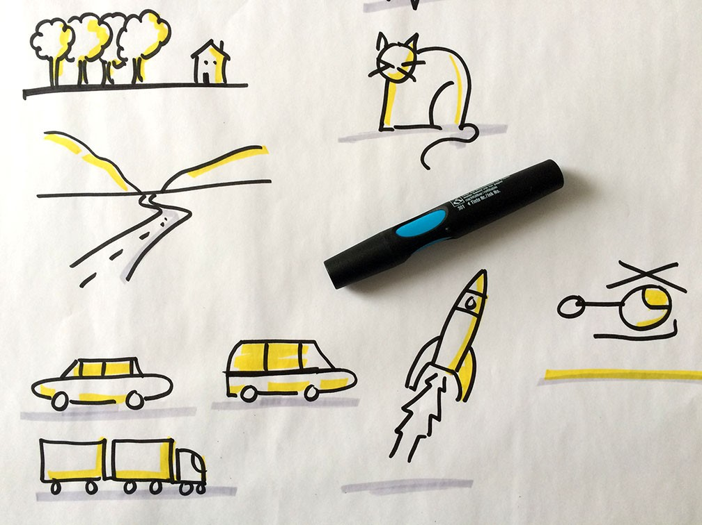
Figure 1. IDSA Caption. Visuals.
Captions go under the respective tables and figures. All figures and tables are aligned to the left of a page or column and appear either on the same page as the first reference to the figure or table or on the first page after the first reference. Captions use style ‘IDSA CAPTION’, text should succinctly describe the image.

- CITATIONS AND REFERENCES
If appropriate for your workshop, please include a references section at the end of your submission in alphabetical order. Note that references may not be necessary for all workshop submissions. Formatting for citations and references should follow standard APA style. When citing a website, please enter the date you last viewed it, as the content may change.

Reference APA 7 style guide: www.apastyle.org and www.mendeley.com/guides/apa-citation-guide

- REFERENCES
Please use APA 7 style, see examples below: 1. Journal, 2. Book, 3. Website, 4. Dictionary, 5. You-tube video, 6. Author journal article, 7. Author conference paper.
Hortin, J. A. (1984). Visual literacy and visual thinking. In L. Burbank, & D. Pett (Eds.) Contributions to the study of visual literacy. IVLA.
Kelley, T., & Kelley, D. (2013). Creative confidence, unleashing the creative potential within us. Crown Business
Lamm, E. (2020). Workshops. Eva-Lotta Lamm. https://www.evalotta.net/workshop-visualthinking
Merriam-Webster. (n.d.). Communication. In Merriam-Webster.com dictionary. Retrieved October 13, 2020, from https://www.merriam-
Smith, R. (2012, August 31). Drawing in class: Rachel Smith at TEDxUFM [Video].YouTube. https://www.youtube.com/watch?v=3tJPeumHNLY
Author (2020). Journal article.
Author (2020). Conference paper.

