paper submission TITLE [IDSA PAPER TITLE]
Subtitle [IDSA PAPER SUBTITLE]
Author NAMES [IDSA AUTHOR] ARE NOT TO BE INCLUDED IN THIS DOCUMENT FOR REVIEW BY THE SELECTION COMMITTEE
affiliations [IDSA AFFILIATION] ARE NOT TO BE INCLUDED IN THIS DOCUMENT FOR REVIEW BY THE SELECTION COMMITTEE
PAPER ABSTRACT: [IDSA ABSTRACT] This abstract should be no longer than 250 words. It should provide an overview of the study background and methodology, as well as a summary of findings and contributions to design and connections with the conference theme. This template provides guidelines to format the workshop submission. Please follow the instructions and pre-set formatting styles. Workshop submissions must be submitted only as .PDF. See below for details regarding formatting, submission logistics and general guidelines.

KEYWORDS: [IDSA ABSTRACT] List up to five primary words/theme words found within this paper, separated by commas Industrial Design Education, User research, Artificial Intelligence in User Research, Design Process, User-Centered Framework, Academic Constraints, Empathetic Design, Innovation in Education.

- Layout of the paper & Submission guidelines [IDSA Heading 1]
[IDSA BODY] This template provides guidelines to format your paper submission. Please follow these instructions and pre-set formatting styles. Papers submitted that do not adhere to the formatting details outlined (and demonstrated) in this document may not be accepted by the review committee.

The paper size is US Letter (8.5 x 11 in). The document margins are 1 inch. The standard font to be used for the IDSA paper submissions is Calibri. Preformatted text styles are included in this document.

For full papers: 3000–4000 words (including figures and tables, excluding abstract and references).

Paper title
For full papers, please name your PDF file: Paper_(Presentation Title).pdf.
Title maximum 40 characters (including spaces). If longer, your title will get cut short and will be hard to search. Images may be included in your .PDF submission. Additionally, (1) one .jpeg image will be uploaded through the online submission portal to be used to be used as a ‘thumbnail’ image to represent your paper online if published. Pages are numbered in the footer as shown in this template. Please do not alter the page number or IDSA logo.

Only Adobe .PDF documents will be accepted in this call for papers. Papers must be submitted via the online submission form.

Please refer to https://www.idsa.org/conference-details/2026-idc-education-symposium for important information about the IDSA IDC (International Design Conference) & Education Symposium.
- Text styles
The styles part of the ‘Formatting Palette’ contains predefined styles for each possible section of your Education Paper submission. Please do not alter header and footer of the paper. All text is left aligned. The following list presents the components used and corresponding styles:
- The paper title is bold 20pt, all caps, line spacing exactly 13pt, aligned left. Style ‘IDSA PAPER TITLE.’
- Abstract and keywords are italic, 9pt, line spacing exactly 14pt, align left. Style ‘IDSA ABSTRACT.’
- The header is bold 12pt, all caps, single spacing, aligned left, space before 22,5pt, after 7,5pt. Style ‘IDSA HEADING 1’.
- The subheading is 11pt in all caps, single spacing, aligned left. Style ‘IDSA SUBHEADING.’
- Author is bold 9pt, all caps, aligned left (note: Do not list authors for paper proposals)
- Affiliation is 9pt, all caps, aligned left (note: Do not list affiliations for paper proposals)
- Body text is 11pt, line spacing exactly 14pt, aligned left. Style ‘IDSA BODY.’
- Bullet lists are body text, hanging 0.2in, space before 5pt. Style ‘IDSA PAPER bullet list.’
- Image Captions are italic, 8pt, line spacing exactly 10pt, aligned left. Style ‘IDSA CAPTION.’
- References are 9pt, line spacing exactly 10pt, aligned left, space after 3pt, hanging 0.3”. Style ‘IDSA REFERENCES.’
- Section heads
Section Header is bold 12pt, all caps, single spacing, aligned left, space before 22,5pt, after 7,5pt. Style ‘IDSA HEADING 1’.

4.1 Subsection head
Subheading is 11pt all caps, single spacing, aligned left. Style ‘IDSA SUBHEADING.’
- Figures and Tables
Figures and tables can appear within the text, left aligned. Use ‘IDSA IMAGE PLACEMENT’.
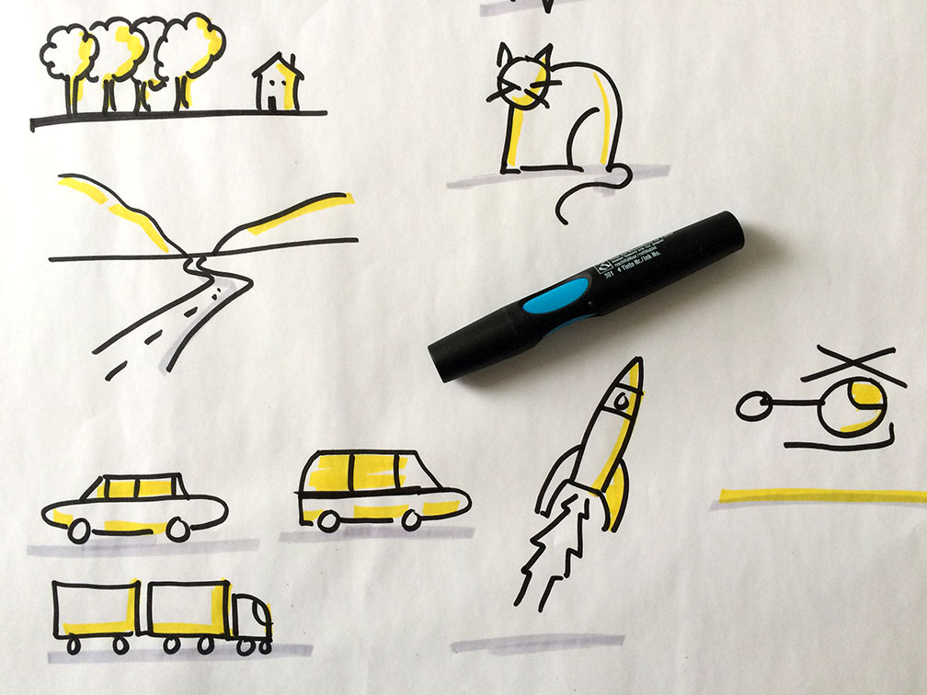
Figure 1. IDSA Caption. Visual example..
Captions go under the respective tables and figures. All figures and tables are aligned to the left of a page or column and appear either on the same page as the first reference to the figure or table or on the first page after the first reference. Captions use style ‘IDSA CAPTION’, text should succinctly describe the image.
- citations and References
In the references section at the end, please include references to all works cited in the running text organized in alphabetical order. Do not include works that are not cited in the text. Formatting for citations and references should follow standard APA style.

Please use “IDSA References” paragraph style. Follow APA 7 guidelines, see examples online here: https://apastyle.apa.org/style-grammar-guidelines/references/examples and also examples below (author’s name has been changed to type of citation). All citations should include a DOI URL if possible. References should be listed alphabetically.

Journal [IDSA REFERENCES], J. S., Her, M., Moreno, G., Perez, C., & Yelinek, J. (2019). Emotions in storybooks: A comparison of storybooks that represent ethnic and racial groups in the United States. Psychology of Popular Media Culture, 8(3), 207–217. https://doi.org/10.1037/ppm0000185
Book, L. M. (2019). The psychology of prejudice: From attitudes to social action (2nd ed.). American Psychological Association. https://doi.org/10.1037/0000168-000
Newspaper, B. (2019, March 22). Can we get better at forgetting? The New York Times. https://www.nytimes.com/2019/03/22/health/memory-forgetting-psychology.html
Conference Presentation, A. C., Jr., Garbarino, J., Bocanegra, E., Kinscherff, R. T., & Márquez-Greene, N. (2019, August 8–11). Gun violence: An event on the power of community [Conference presentation]. APA 2019 Convention, Chicago, IL, United States. https://convention.apa.org/2019-video
Artwork, V. (1889). The starry night [Painting]. The Museum of Modern Art, New York, NY, United States. https://www.moma.org/learn/moma_learning/vincent-van-gogh-the-starry-night-1889/
YouTube. (2020, June 5). World’s leading vaccine expert fact-checks COVID-19 vaccine conspiracy: Stay curious #22 [Video]. YouTube. https://www.youtube.com/watch?v=WQdLDMLrYIA
Webpage on a news website, C. (2019, October 31). Why some people with anxiety love watching horror movies. HuffPost. https://www.huffpost.com/entry/anxiety-love-watching-horror-movies_l_5d277587e4b02a5a5d57b59e
Webpage with organizational group author World Health Organization. (2018, May 24). The top 10 causes of death. https://www.who.int/news-room/fact-sheets/detail/the-top-10-causes-of-death
AI reference Anthropic. (2025). Claude 4.5 Sonnet [Large language model]. https://claude.aiopens in new window
AI chat reference OpenAI. (2026, February 10). Top 10 writing topics for high school graduates [Generative AI chat]. ChatGPT. https://chatgpt.com/share/698b9233-1b58-8008-858d-cede516f4240

